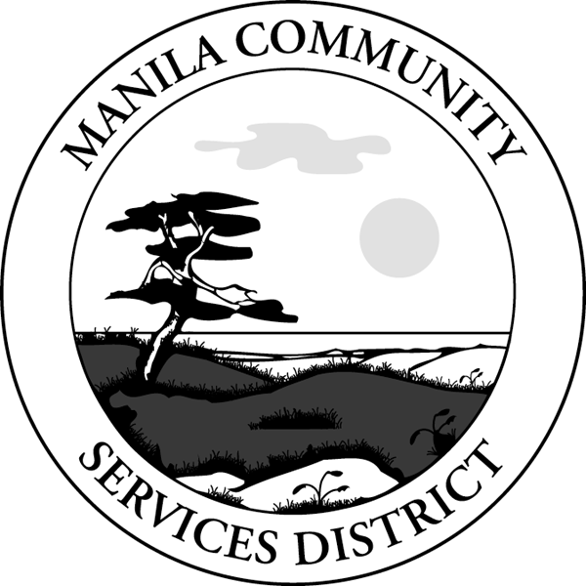

Manila Community Services District
1901 Park St. | Arcata, CA 95521 | 707-444-3803 | Fax 707-444-0231
District Website: www.manilacsd.com MANNAwww.manilacsd.comwww.manilacsd.com

WATER AND SEWER SERVICE APPLICATION
(DOUBLE-SIDED FORM)

__________________________________________________________________________
Name Date Service Effective

__________________________________________________________________________
Service Address

__________________________________________________________________________
Mailing Address

__________________________________________________________________________
Telephone Number Email Address E-bill or Mailed

__________________________________________________________________________
Social Security Number Driver’s License Number/State

SHUT OFF WARNING: Do you authorize MCSD to send text messages to advise if service will be disconnected for non-payment Circle One: YES NO
IF YES CELL PHONE #______________________ SERVICE PROVIDER______________

Circle One: Owner Agent Tenant
***Information for Notification in Case of Emergency***

__________________________________________________________________________
Employer Telephone Number
__________________________________________________________________________
Relative or Friend Telephone Number
__________________________________________________________________________
Property Owner / Agent, if renting Telephone Number
***For Staff Use Only***

 | Amount | Date Paid
Deposit – Refundable – See Reverse $150.00/Unit
Initiate Service Fee – Non Refundable $30.00

Meter No.: |  | Account No.:
 |  | Service ID:
Meter Reading: |  | Meter Type:
Reading Date: |  | No. of Services:
Circle One: | Residential/Commercial | Route & Reading Sequence
MANILA COMMUNITY SERVICES DISTRICT
Water and Sewer Service Application

It is the customer’s responsibility to be sure that fixtures are off
within the property when service is turned on.
District retains sole ownership of all pipes and fittings from the water main up to and including the water meter. A property owner is responsible for all service lines downstream of (after) the meter. The applicant will be required to accept such conditions of pressure and service as are provided by the distribution system at location of requested service and to hold the District harmless for any damages arising out of low or high pressure conditions or interruptions of service.
The customer will be liable for any damage to the service facilities when such damage is from causes originating on the premises by an act of the customer or his tenants, agents, employees, contractors, licensees or permittees, including the breaking or destruction of locks by the customer or other on or near a meter.

PAYMENT OF BILLS: The applicant agrees to pay all charges within 20 days after billing due date up through the date termination of services is requested. A late charge of $10.00 will be added to accounts that become past due. Service may be discontinued without further notice if payment is past due. A $45.00 fee will be charged to accounts turned off for nonpayment. To be reconnected after shut off for nonpayment, customers will be required to pay all past due and current charges and disconnect fees plus an additional deposit as specified in the DEPOSIT section below.
A $40.00 disconnect fee will be charged to customers who no longer require service at the account location, but who failed to notify the District to discontinue service.

CURRENT RATES: Sewer is a flat rate of $41.39 per month for each residential unit. Water has a base rate of $32.11 plus $.83 per 100 cubic feet of water used. Meters are read between the 19th and 25th of each month. Customers are responsible for consumption due to leaks on customers’ side of the meter.

DEPOSIT: A deposit of $150.00 is required to establish service for each unit. Deposits will be credited back to accounts when the account is closed. An increased deposit will be required if an account is shut off for nonpayment. The required additional deposit will be up to three times the monthly minimum charges if service is discontinued.

Your signature indicates authorization for MCSD to use the information presented on this form. All information will be kept securely.

_______________________________________________________________________
Signature Date

_______________________________________________________________________
Signature Date

